**DESIGN AND IMPLEMENTATION OF AN ORDER REVIEW E-COMMERCE SYSTEM WITH PAYMENT ON DELIVERY SUPPORT**

BY

**OKEREKE** CHIMEMEZIEM DANIEL

BU/23A/IT/8106

The Faculty of Computing & Applied Sciences

BAZE UNIVERSITY

ABUJA

SEPTEMBER, 2025

**DESIGN AND IMPLEMENTATION OF AN ORDER REVIEW E-COMMERCE SYSTEM WITH PAYMENT ON DELIVERY SUPPORT**

Thesis Submitted in Partial Fulfillment of the Requirement for the Degree of

B. Sc.

In

Computer Science [INFORMATION SYSTEM MANAGEMENT]

By

**OKEREKE** CHIMEMEZIEM DANIEL

To

*The Faculty of Computing & Applied Sciences*

Baze University, Abuja

SEPTEMBER, 2025

**DECLARATION**

This is to certify that this project entitled **Design And Implementation Of An Order Review E-Commerce System With Payment On Delivery Support**, which is submitted by **Okereke Chimemeziem Daniel** in partial fulfilment of the requirement for the award of degree for B.Sc. in Information System Management to the Department of Computer Science, Baze University Abuja, Nigeria, comprises of only my original work and due acknowledgement has been made in the text to all other materials used.

Date: 09/ 2025 Okereke Chimemeziem Daniel:

**APPROVED BY** ……………………………

**Head**

Department of Computer Science

**CERTIFICATION**

This is to certify that this project entitled **Design And Implementation Of An Order Review E-Commerce System With Payment On Delivery Support**, which is submitted by **Okereke Chimemeziem Daniel** in partial fulfilment of the requirement for the award of degree for B.Sc. in Information Technology to the Department of Computer Science, Baze University Abuja, Nigeria is a record of the candidate’s own work carried out by the candidate under my/our supervision. The matter embodied in this project is original and has not been submitted for the award of any other degree.

Date: Supervisor: Dr. Usman Abubakar

**APPROVAL**

This is to certify that the research work, **Design And Implementation Of An Order Review E-Commerce System With Payment On Delivery Support** and the subsequent preparation by **Okereke Chimemeziem Daniel** with **BU/23A/IT/8106** has been approved by the Department of Computer Science, Faculty of Computing and Applied Science, Baze University, Abuja, Nigeria.

By

Dr Usman Abubakar Date/Sign

Supervisor

Dr Abubakar Idris Usman Date/Sign

Head, Department of Compuer Sciences

Prof Rufai Aliyu Yauri Date/Sign

Dean, Faculty of Computing and Applied Science

External Examiner Date/Sign

**DEDICATION**

[This is the dedication page.]

**ABSTRACT**

[The abstract provides a clear summary of the project, indicating both content and tone of the project. An abstract includes the method(s) used to analyze the problem, a brief description of the research design, a listing of the key results, a brief description of the significance of the results, selected key conclusions. First-person narrative should not be used in the abstract.]

# TABLE OF CONTENT

**DECLARATION** 3

**CERTIFICATION** 4

**APPROVAL** 5

**DEDICATION** 6

**TABLE OF CONTENT** 8

**LIST OF TABLES** 11

**LIST OF FIGURES** 12

**LIST OF ABBREVIATION** 13

**CHAPTER 1: INTRODUCTION** 2

1.1 Overview 2

1.2 Background and Motivation 4

1.2.1 Background 4

1.2.2 Motivation 4

1.3 Statement of the Problem 6

1.4 Aims and Objectives 7

1.4.1 Aim 7

1.4.2 Objectives 7

1.5 Significance of the Project 8

1.6 Project Risks Assessment 9

1.7.1 Scope 10

1.7.2 Project Organization 10

**CHAPTER 2: LITERATURE REVIEW** 12

2.1 Introduction 12

2.2 Historical Overview 13

2.3 Related Work 16

2.4 Summary 18

**CHAPTER 3: REQUIREMENTS, ANALYSIS, AND DESIGN** 19

3.1 Overview 19

3.2 Proposed Model 20

3.3 Methodology 21

3.3.1 Date Gathering Method 21

3.4 Tools and Techniques 23

3.5 Ethical Consideration 25

3.6 Requirements Specifications 26

3.6.1 Functional Requirements Specifications 26

3.6.2 Non-Functional Requirement Specifications 27

3.6.3 System Requirements Specifications 28

3.7 System Design 30

3.7.1 Application Diagram 30

3.7.2 Use case diagram 31

3.7.3 Entity-Relationship Diagram (ERD) 33

3.7.4 Data Design 34

3.7.5 Activity Diagrams 36

3.7.6 Data Flow Diagram 37

3.7.7 Control Flow Diagram 37

3.7.8 User Interface Design 39

3.9 Summary 42

**CHAPTER 4: TESTING AND IMPLEMENTATION** 43

4.1 Overview 43

4.2 Main Features 44

4.3 Implementation Problems 53

4.4 Overcoming Implementation Problems 54

4.5 Testing 55

4.5.1 Test Plans (For Unit, Integration and System Testing) 55

4.6 Use Guide 60

4.6.2 User Guide 60

4.7 Summary 63

**CHAPTER 5: DISCUSSION, CONCLUSION, AND RECOMMENDATIONS** 64

5.1 Overview 64

5.2 Objective Assessment 65

5.3 Limitations and Challenges 66

5.4 Future Enhancements 67

5.5 Recommendations 68

5.6 Summary 69

**REFERENCES** 70

**Appendix A - Project Document** 73

Background and Motivation 73

Statement of the Problem 74

**Appendix B – Model Training and Data Collection** 75

**Appendix C- Source Codes** 80

**LIST OF TABLES**

TABLE 1.1 *PROJECT RISK ASSESSMENT*

TABLE 3.1 *FUNCTIONAL REQUIREMENTS*

TABLE 3.2 *NON-FUNCTIONAL REQUIREMENTS*

TABLE 3.3 *SOFTWARE REQUIREMENTS*

TABLE 3.4 *HARDWARE REQUIREMENTS*

**LIST OF FIGURES**

FIGURE 3.1 - *APPLICATION DIAGRAM OF THE USER VIEW*

FIGURE 3.2 - *APPLICATION DIAGRAM OF THE ADMIN VIEW*

FIGURE 3.3 – *USE CASE DIAGRAM*

FIGURE 3.4 – *ERD (ENTITY-RELATIONSHIP DIAGRAM) DIAGRAM*

FIGURE 3.5 – *ACTIVITY DIAGRAM SHOWING HOW THE USER WOULD INTERACT WITH THE SYSTEM*

FIGURE 3.6 - *DATA FLOW DIAGRAM*

FIGURE 3.7 – *USER CONTROL FLOW DIAGRAM*

**LIST OF ABBREVIATIONS**

**CHAPTER ONE**

**INTRODUCTION**

* 1. Overview

E-commerce (Electronic commerce) means a business conducted using the internet (Jain, V., 2021). E-commerce aids clients to be able to buy goods and services using internet technologies and its related structure by providing a market place deprived of a physical restraint and without physical interaction (Odunola, 2013). Customers and merchants are not visible to one another, but can all be participating in the same market place at the same time and with an estimate of over two billion people connected to the internet (Miniwatts Marketing Group, 2011), the reach of an e-commerce service is huge.

E-commerce has revolutionized global trade by enabling transactions over the internet, eliminating geographical and physical barriers (Rayport, J. F., & Jaworski, B. J. 2003). However, in markets like Nigeria, where cash transactions dominate and trust in digital payments is low, traditional prepaid e-commerce models face significant challenges. This project focuses on the design and implementation of an order review e-commerce system with payment on delivery (POD) support, addressing the unique needs of cash-reliant consumers while enhancing trust and reducing fraud risks.

However, according to certain unverified news sources, POD is thought to be a commonly used payment mechanism in Nigeria for transactions between consumers and online merchants. In Nigeria, POS and ATM machines typically accept debit and credit cards for cash withdrawals. The payment process is made more difficult by the fact that many bank cards do not enable payments on e-commerce websites at all, or if they do, they require prior activation before a transaction can be made using phone banking.

1.2 Background And Motivation

1.2.1 Background

The Nigerian e-commerce sector has experienced rapid growth, driven by increasing internet penetration from 1% in 2000 to 29.5% in recent years. Despite this growth, adoption of digital payments remains low, with over 80% of transactions still cash-based. Early e-commerce platforms in Nigeria struggled due to consumer doubt about online payments, product quality, and delivery reliability.

Nigerian consumers lack the technological know-how necessary for internet purchasing because the majority of the population lives in rural regions and the country has a very low literacy rate. Customers are also less trusting when it comes to disclosing their e-payment details online. As a result, POD is seen as a preferred option for internet purchasing. Customers that choose the POD payment option choose to pay for the item after it is delivered.

Customers that choose POD can make purchases without using cash. A logistics firm is enlisted to deliver the goods and collect payment once the retailer sends out an invoice along with the shipment. As a result, this strategy gives the client confidence and security.

The introduction of Pay on Delivery (POD) by pioneers like Jumia.com.ng marked a turning point, enabling customers to inspect products before payment. This model significantly boosted e-commerce activity by aligning with local preferences for cash transactions and mitigating trust barriers. However, challenges such as order fraud, high return rates, and logistical inefficiencies persist, necessitating a more robust system integrating order review mechanisms with POD.

1.2.2 MOTIVATION

This project is motivated by the dominance of cash transactions in Nigeria and similar markets. Low trust in prepaid e-commerce due to fears of fraud, late deliveries, and substandard products. The success of POD models in increasing conversion rates but lacking advanced features like real-time order review. The need for fraud-resistant systems to reduce losses for merchants.

By combining order review functionalities with POD, this system aims to enhance transparency, reduce disagreements, and improve operational efficiency for e-commerce platforms.

1.3 STATEMENT OF THE PROBLEM

Online payments, often known as e-payments, are made, received, and processed electronically over the Internet. E-commerce transactions can be made using a variety of mobile-enabled payment methods, such as credit cards, prepaid cards, smart cards, e-cash (digital currency), and e-checks (digital checks). Although credit cards are the most widely used electronic payment method worldwide (Kou, 2013), previous studies have shown that POD is one of the most popular e-commerce payment methods in countries like Malaysia, China, India, and the United Arab Emirates.

Current e-commerce systems in cash-reliant markets face critical issues such as high return rates where customers cannot modify orders after checkout, leading to mismatched expectations, fraud risks: due to dishonest buyers refuse payment upon delivery, causing revenue loss, and operational inefficiencies: as manual verification of POD orders increases costs and delays. Therefore, to improve e-commerce, cash on delivery is the most popular choice among consumers. (Amobi, 2023; Sasu, 2022; Fastercapital, 2023).

This project addresses these gaps by introducing an intermediate order review stage and automated fraud detection to streamline POD transactions.

1.4 AIMS AND OBJECTIVES

1.4.1 AIM

To design and implement an Order Review E-Commerce System with POD support, improving customer trust, reducing fraud, and optimizing logistics for cash-based transactions.

1.4.2 OBJECTIVES

1. Todevelop an order review interface that allow customers to confirm or modify orders before delivery.
2. To enhance delivery tracking by providing real-time updates on order status and payment collection.
3. To improve backend efficiency through automating order verification and reducing manual overhead.

1.5 SIGNIFICANCE OF THE PROJECT

The significance of this project is rooted in its direct response to the key economic and social barriers hindering the growth of e-commerce in cash-reliant economies such as Nigeria. The proposed system offers a practical solution that provides tangible benefits to businesses, consumers, and the broader digital ecosystem.

For merchants, the system holds significant economic and operational value. By requiring customers to confirm their purchase intent before dispatch, it directly mitigates the high financial losses associated with fraudulent orders and failed deliveries. Furthermore, it improves operational efficiency by automating the order verification process, which reduces the need for manual confirmation calls and enables faster, more accurate order fulfillment.

From the consumer's perspective, the project's primary significance lies in its ability to build trust and confidence. Allowing customers to review and modify orders before shipment directly addresses the widespread fear of receiving incorrect or substandard products. This transparency creates a more user-centric and reliable purchasing journey, leading to higher customer satisfaction and encouraging repeat business from a previously skeptical user base.

On a broader scale, this project serves as a functional blueprint for adapting e-commerce technology to other emerging markets that face similar challenges of low digital payment adoption and trust deficits. Academically, it offers a valuable case study on localizing information systems, providing a foundation for future research into developing more robust and culturally relevant e-commerce solutions.

1.6 PROJECT RISKS ASSESSMENT

|  |  |  |
| --- | --- | --- |
| **RISK** | **RISK MITIGATION** | **IMPACT** |
| Low User Adoption | Implementing a user-centric and intuitive design to accommodate users with varying technical know-how. | High |
| Security Breaches | Using robust security measures like HTTPS, data encryption, and secure authentication to protect sensitive user data and build trust. | High |
| Technical Implementation Issues | Adopting a modular three-tier architecture and conducting thorough unit, integration, and system testing to ensure stability | Medium |
| Scope Creep | Maintaining a clearly defined project scope that outlines all included and excluded features to prevent project delays and budget overruns | Medium |

Table 1.1 *Project Risk Assessment*

1.7 SCOPE/PROJECT ORGANIZATION

1.7.1 SCOPE

This project covers:

1. Frontend Development: User interfaces for order review, payment selection, and delivery tracking.
2. Backend Systems: Secure databases for order management, fraud detection algorithms, and logistics coordination.
3. POD Workflow: Processes for delivery confirmation, cash collection, and receipt generation.
4. Security Measures: Encryption, OTP verification, and AI-based fraud prevention.

1.7.2 PROJECT ORGANIZATION

1.8 SWOT ANALYSIS

The project focused on the Nigerian market (though adaptable to similar regions), and excludes third-party payment gateways for prepaid transactions. By addressing these areas, the system aims to bridge the gap between digital convenience and cash-based trust, fostering sustainable e-commerce growth in emerging markets.

**CHAPTER TWO: LITERATURE REVIEW**

2.1 INTRODUCTION

E-commerce is now a major business and has beyond its early stages. It is now a logical component of multi-channel initiatives to increase sales and boost profitability. Instead of performing the same things in a different way, firms are rethinking their entire processes to fully profit from e-commerce Bakar, R., Fauziyah, N., & Rahmat, A. (2025).

The idea behind e-commerce is to use the Internet to do business more efficiently and effectively. It involves granting clients-controlled access to your computer systems, enabling them to personalise goods and services, and ensuring timely delivery of goods and services, (Nasution, M. D. T. P., & Surya, D. H. (2025)). These individualised automated services are of considerable financial benefits to a business in the form of higher revenue and decreased cost of doing business (Okofu, S. N., Bisina, J., Okumoku-Evroro, O., & Akazue, M. I. (2024)).

E-commerce's explosive growth has changed how people purchase throughout the world and changed the retail landscape by providing unmatched accessibility, ease, and a variety of payment methods. Even while digital payment methods like bank transfers, credit cards, and mobile wallets have become increasingly popular, Cash on Delivery (COD) is still the most common method in many developing nations. As an alternative to pre-payment options, which many customers find unsafe or cumbersome, POD enables customers to pay for items upon delivery. In areas with inadequate digital infrastructure or where consumers show little faith in digital payment systems, this payment alternative has become especially important (Vandiny et al., 2022).

POD reduces worries about fraud, defective goods, or non-delivery by allowing customers to inspect and accept items prior to payment, which increases confidence in online transactions. According to Pencarelli et al. (2018), POD's continued popularity, particularly in emerging nations, highlights its significance as a payment mechanism that fills in gaps in infrastructure, consumer readiness for fully digital transactions, and confidence. Many consumers believe that POD is a safer option than online payment methods, especially in situations where data breaches and e-commerce fraud are major worries. The ease of POD transactions, which remove the need for prior financial commitments and lower entry hurdles for conservative or first-time online customers, further reinforces this notion.

2.2 HISTORICAL OVERVIEW

The historical background of EC and its first and subsequent consequences can be studied with the help of knowledge gained from the history of contemporary trade. The historical background that currently favours EC is globalisation (Kabir, M. A., Saidin, S. Z., & Ahmi, A. 2015). Certain practices that facilitate business-to-business (B2B) electronic commerce were established in part due to the rise of network organisations. Efficiency in the relationship between production and consumption is promoted by EC's first order effect, which is the reduction of transaction costs and time. While some higher order effects are already in place, others are currently being developed, and yet others could result in institutional changes (Panetta, I. C., Leo, S., & Delle Foglie, A., 2023).

Even though the concept of e-commerce is relatively new in comparison to other phenomena, it would still be beneficial to discuss its history, no matter how brief. It is generally accepted that the development of the Electronic Data Interchange, or EDI, in the 1960s served as a kind of launching pad for the development of e-commerce. Important company information was transferred and computerised transactions were made easier by the EDI. Nonetheless, there are three distinct eras in the history of e-commerce, (Heng, M. S. 2003).

Innovation from 1995 to 2000: The first widespread use of the web for product advertising occurred in 1995, marking the beginning of e-commerce's early years of explosive growth and innovative breakthroughs. During this period, numerous internet-based businesses were founded with billions of dollars as their initial investment. Stakeholders like computer scientists and information technologists thought that the tremendous early success of e-commerce was proof of the amazing work they had done over the course of more than 40 years, from the creation of the first internet to the PC to local area networks. However, it's important to remember that only 10% of the 1995-founded internet companies have survived, and even fewer are successful.

Alliance from 2001 to 2006: During this time, a business-driven strategy became more important. Instead of developing new brands, major firms began concentrating on ways to improve their market positions. During that time, traditional means were the main source of funding for new firms. The more successful companies employed a combined "bricks and clicks" strategy, combining traditional sales efforts with online efforts, while intermediaries grew stronger and retail giants dominated e-commerce.

2006–Present Reinvention: In 2006, e-commerce began a third phase that continues to this day. This era is still driven by business, but it is also driven by the community, customers, and audiences. Furthermore, as established Web businesses catch up, first-mover advantages are resurfacing in new areas, and other big online companies are increasingly joining the market and purchasing early-stage companies like MySpace and YouTube through buyouts (Achiando, H. A. 2019). Additionally, the variety of e-commerce products is expanding. particularly in retail clothing, appliances, entertainment, travel, information clearing houses, and home furnishings, while internet sites keep increasing their profitability by improving their business models and utilising the Internet's advantages.

2.2.1 ADOPTION OF PAY ON DELIVERY (POD)

In e-commerce, cash on delivery (COD) is still a common payment option, especially in areas where digital payment systems encounter issues with infrastructure, accessibility, and confidence. COD lowers worry about fraud and product quality problems by allowing clients to pay for their orders only after receiving and confirming the items. Because of this aspect, COD is especially attractive in developing nations where digital payment methods are less dependable or easily accessible and consumer trust in online merchants is still developing (Hendricks, S., & Mwapwele, S. D. 2024).

Consumer trust and the perception of risk reduction are two of the main factors influencing the adoption of POD. By allaying consumers' concerns about online payment fraud and guaranteeing that they receive the right items before completing the transaction, POD offers a safer option. Research indicates that customer opinions towards payment systems are significantly influenced by trust, particularly when perceived risks are large, (Yusuf, A., et al., 2022). In this regard, POD is a useful tactic for building consumer trust in emerging economies since it upholds consumer confidence and encourages the expansion of e-commerce in settings where trust is lacking (Mumu, J. R., et al., 2022).

2.3 RELATED WORK

Anjum and Chai (2020) outline the factors that influence Pakistani e-commerce shoppers' use of the payment-on-delivery approach. The study investigated the key elements and determinants that influence Pakistani consumers' decision to buy POD when making purchases on online marketplaces. It has been noted that Pakistani consumers choose POD as a payment method since it makes them feel comfortable and secure.

According to a study by Alfarizi and Sari (2023), behavioural intents will encourage long-term use of the POD system because of the influence of pricing value, habits, social incentive, hedonic motivation, information quality, and privacy security methods. The study found that advertising is crucial in conveying the advantages of the POD system. To ensure that the usage of POD does not negatively impact consumers, business units in the market, or courier missions, a POD system must be developed that includes ongoing public perception improvement. To ensure that there is no criminality, increased transaction security and user privacy when using the POD system must be taken into account.

Design and implementation of e-commerce site for online shopping is presented by (Sidhartha R.V. 2014). The project lets registered users examine the many things that are offered and use PayPal to buy the products they want right now. They may even place an order and choose to pay later.

The idea presented by (Usman P.J. 2022) aims to create an e-commerce website for the sale of products online with profitable results. Users will be able to select from a producer category on this website based on their demands. To facilitate the procedure, a shopping cart is made available to web registered users, who can purchase items from the product list and have them shipped just by utilising their computer and the Internet to be in their current location.

"A value-based adoption model approach to the adoption of cash on delivery payment method in e-commerce shopping" (Rihidima, L. V. C., et al., 2022). The study looks at how compatibility may affect the relationship between perceived value and adoption intention as well as what characteristics can affect adoption intention through perceived value. Additionally, it is hoped that local businesses would be able to provide new services that are relevant and beneficial to customers based on the findings of this research.

Zhang and Wang (2014) examined the variables affecting how customers behave when they shop online. The study's findings showed that while personal attitude, domain-specific novelty, and regulations all have a favourable impact on customers' attitudes towards online purchasing, risk of losing money and not receiving the requested item have a negative impact.

In order to determine the risks and losses incurred by merchants in an unsuccessful transaction, Sabastina 2024 presents an exploratory investigation of cash payment on the delivery of electronic commerce transactions using a questionnaire instrument on major e-commerce shops in Nigeria (Jumia, Konga, PayPorte, Slot.ng, JijiNigeria, etc.). According to the survey, the hazards include fraudulent orders, chargebacks in unsuccessful payment-on-delivery transactions in electronic commerce, theft while carrying significant sums of money, product packaging and unpacking from unfulfilled transactions, and item returns.

**2.4 SUMMARY**

This chapter offers a survey of the literature that discusses how e-commerce has changed from its beginnings to its current position in multi-channel business strategy. It highlights the continued applicability of POD in poor nations where trust and infrastructure problems impede the adoption of digital payments. Three stages can be used to describe historical e-commerce developments: innovation, alliance, and reinvention. POD adoption is examined with an emphasis on its ability to reduce risk and foster trust. The variables impacting POD adoption, merchant obstacles, and system design considerations that could improve transaction security, efficiency, and customer happiness are highlighted in the study of related papers.

# CHAPTER THREE: REQUIREMENTS, ANALYSIS, AND DESIGN

## 3.1 OVERVIEW

This chapter outlines the requirements gathering, system analysis, and design of the proposed e-commerce system. It covers methodologies, tools, ethical considerations, and detailed system architecture to ensure a robust, user-friendly platform supporting order review and Payment-on-delivery (POD).

## PROPOSED MODEL

The proposed system adopts a hybrid model, which combines the following components:

1. User-Centric Design: Focus on order review/modification before delivery.
2. Payment-on-delivery Verification: Admin-managed payment confirmation.
3. Modular Architecture: Scalable frontend (React.js), backend (Node.js/Django), and the database (MySQL/MongoDB).

## 3.3 METHODOLOGY

* + 1. Method 1: Interviews

Interviews were conducted with e-commerce vendors and customers within the FCT, Abuja, to identify challenges associated with Payment-on-delivery (POD) systems. A key insight revealed that 68% of users prefer the ability to review their orders before final dispatch.

* + 1. Method 2: Observation

Based on observations of existing platforms such as Jumia and Konga, particularly their Payment-on-delivery workflows, a key finding emerged: there is no provision for real-time order modification after payment is made.

## ****3.4 TOOLS AND TECHNIQUES****

### 3.4.1 Frontend Development

The frontend was developed using React.js,, and HTML/CSS to deliver a responsive and user-friendly interface. Secure communication with the backend was ensured through the use of HTTPS protocols.

### 3.4.2 Backend Development

The backend was implemented using Node.js with the Express.js framework. Key features include secure API endpoints protected by authentication and encrypted database queries to safeguard sensitive information.

### 3.4.3 Database Design

The system database was implemented using MySQL and MongoDB to manage structured and unstructured data efficiently. The database schema includes collections and tables for users, products, orders, and payments. However, to ensure data security, sensitive fields such as passwords and payment details are encrypted.

## 3.5 ETHICAL CONSIDERATIONS

There are four significant ethical considerations must be taken into account when developing and managing an e-commerce website:

1. Data Privacy and Protection: Ensure that customer data is collected, stored, and processed securely, in compliance with data protection regulations, and only with user consent.
2. Secure Payment Processing: Implementing reliable and encrypted payment systems to protect users from fraud, identity theft, and unauthorized transactions.
3. Transparency and Honesty: Providing clear, accurate, and honest information about products, pricing, policies, and business practices to build user trust and maintain integrity.
4. Fair Business Practices: Treating all stakeholders, customers, vendors, and partners, fairly by honoring return policies, avoiding deceptive marketing, and ensuring ethical handling of transactions and disputes.

## 3.6 REQUIREMENT ANALYSIS

The e-commerce website must address both user and business requirements. Users need a responsive and user-friendly interface with secure registration, easy product browsing, payment options (including POD), real-time order tracking, and clear return policies. While, the business perspective, the system should support product and inventory management, secure payment processing, order and delivery tracking, and sales reporting.

## ****3.7 REQUIREMENTS SPECIFICATIONS****

### **3.7.1 Functional Requirements**

### **Table 3.1: Functional requirements**

|  |  |  |
| --- | --- | --- |
| **ID** | **Requirement** | **Description** |
| FR1 | User Account Management | User registration, login, logout, profile update and password reset. |
| FR2 | Product Management | Browse, search, and filter products, View product details etc. |
| FR3 | Shopping Cart and Checkout | Add/remove products to/from cart, update item quantity, proceed to checkout etc. |
| FR4 | Order Management | Place, View history, status, cancel or modify orders before dispatch. |
| FR5 | Payment Processing | Support multiple payment options on POD include, bank transfer. |
| FR6 | Delivery and Logistics | Assign delivery agents, update delivery status and order tracking for customers. |
| FR7 | Admin Panel | Manage users, products, categories, orders and generate reports. |

### **3.7.2 Non-Functional Requirements**

### Table 3.2: Non-Functional Requirements

|  |  |  |
| --- | --- | --- |
| **ID** | **Requirement** | **Description** |
| NFR1 | Performance | System response time less than two seconds. |
| NFR2 | Security | HTTPS for secure communication and AES encryption for sensitive data |
| NFR3 | Scalability | Capable of handling with increasing users, orders, and products. |
| NFR4 | Reliability | Automatic data backup and recovery options |
| NFR5 | Usability | Intuitive and responsive design  include, mobile and desktop compatibility |

## ****3.8 SYSTEM DESIGN****

### **3.8.1 Application Architecture**

The system is designed using a three-tier architecture, which ensures modularity, scalability, and maintainability:

1. Presentation Layer: Responsible for the user interface, built using HTML, CSS, and JavaScript frameworks such as ReactJS to deliver an interactive and responsive user experience.
2. Application Layer: Manages the core business logic and API interactions, implemented using Node.js with the Express.js framework to handle server-side operations and routing.
3. Database Layer: Handles data storage using a MySQL database, with encryption applied to sensitive fields such as passwords and payment details to ensure data security and privacy.

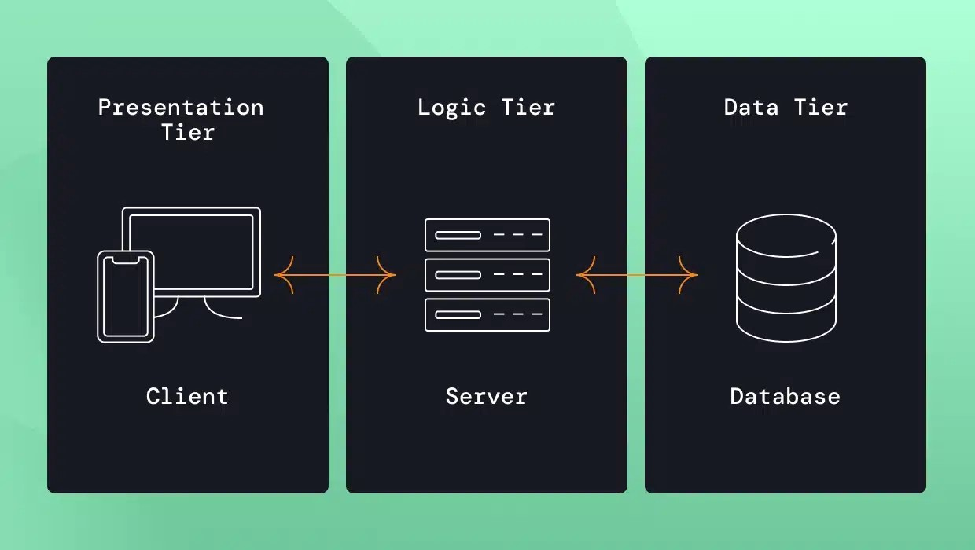

Figure 3.1: Three-Tier Architecture

The figure 3.1, represents a three-tier architecture consisting of the Presentation Layer, Application Layer, and Database Layer, all interconnected through secure APIs to ensure seamless and secure communication.

### **3.8.2 Use Case Diagram**

**The e-commerce system involves three main actors: Customer, Admin, and Delivery Agent.**

1. **The Customer actor can perform the following actions; Register/Login, Browse Products, Add to Cart, Place Order, Select Payment Method, Review/Modify Order, Track Order Status** and **Cancel Order.**
2. **Admin actor is responsible for the following actions; Manage Products, Verify POD Orders, Update Order Status,** and **Generate Reports.**
3. **Delivery Agent actor can perform the following actions including, View Assigned Orders, Confirm Delivery Report Issues.**

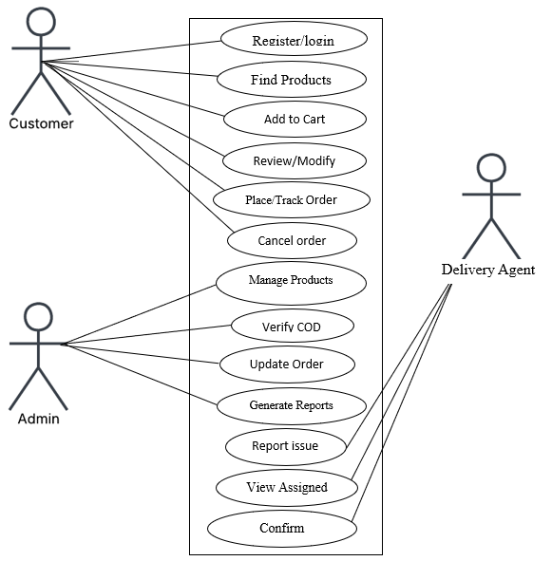

Figure 3.2: Use-case diagram

### **3.8.3 Activity Diagram**

An Activity Diagram for an e-commerce website provides a visual representation of the sequential flow of user actions and system processes. However, it illustrates the progression of activities, including start and end states, decision points and parallel operations.

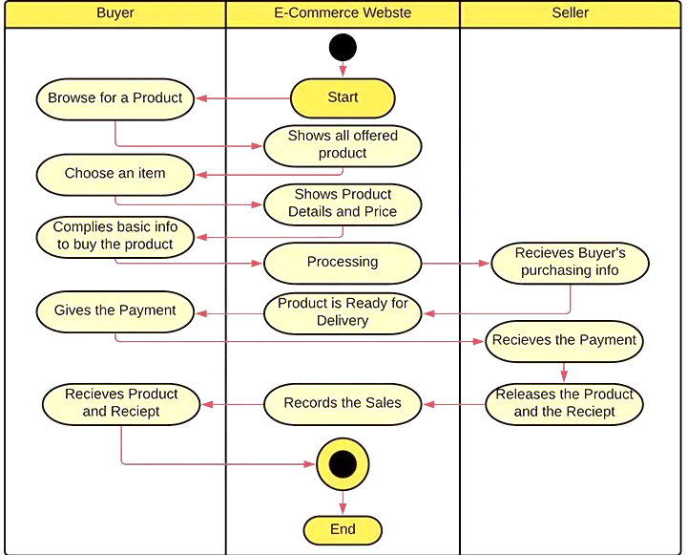

Figure 3.3: Proposed activity diagram

### 3.8.4 Dataflow Diagram (DFD)

A Data Flow Diagram for an e-commerce website depicts the flow of data within the system. However, it outlines how data is exchanged between external entities, internal processes, and data storage components, providing a clear view of system interactions and data movement.

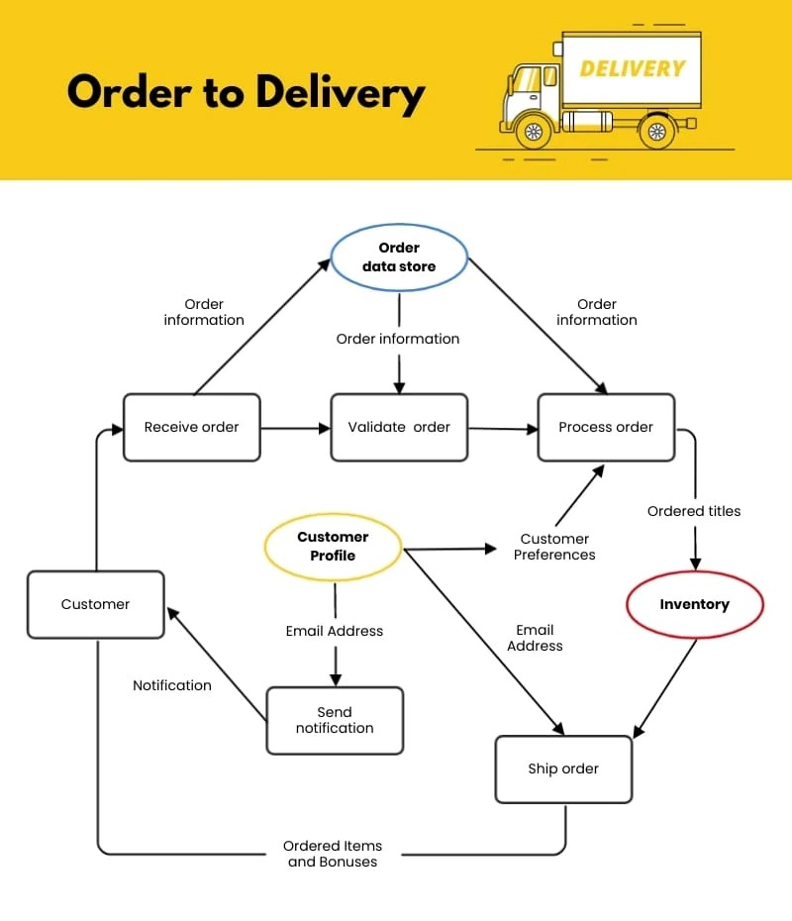

Figure 3.4: Proposed Dataflow Diagram

### 3.8.5 Control Flow Diagram

A Control Flow Diagram for an e-commerce website is a visual representation that illustrates the logical flow of control between different processes or operations within the system.

Figure 3.5: Proposed Control flow diagram

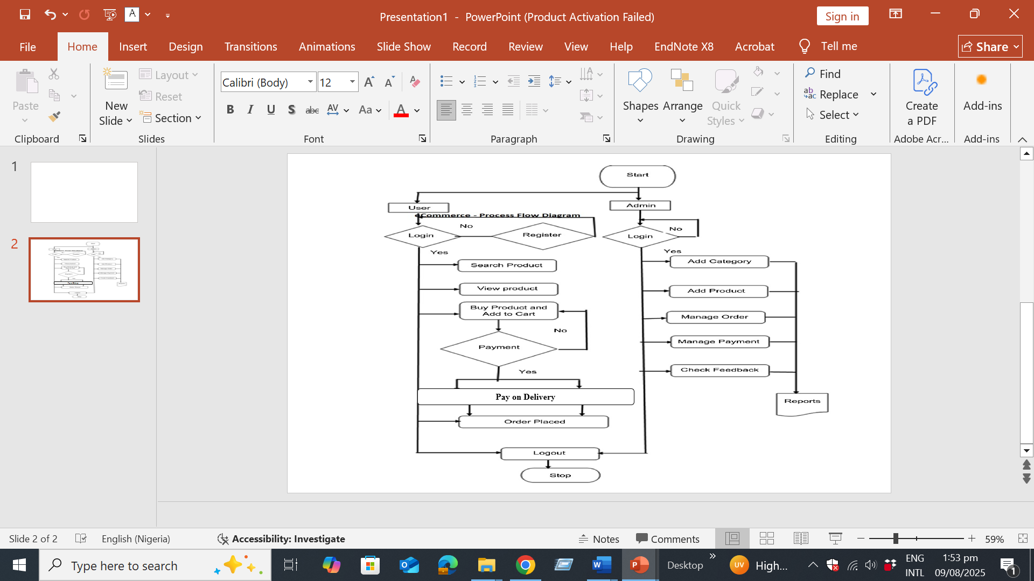

3.8.6 Entity-Relationship Diagram (ERD)

An ERD for an e-commerce website is a graphic model that defines the system's data structure by illustrating the key entities (such as users, products, orders, and payments) and the relationships between them.

However, the relationships in the e-commerce system are as follows: A single User can place multiple Orders, representing a One-to-Many relationship between User and Order. Additionally, each Order can contain multiple Products, and each Product can be part of multiple Orders, forming a Many-to-Many relationship between Order and Product. This many-to-many relationship is typically managed through an intermediary table, such as Order Details.

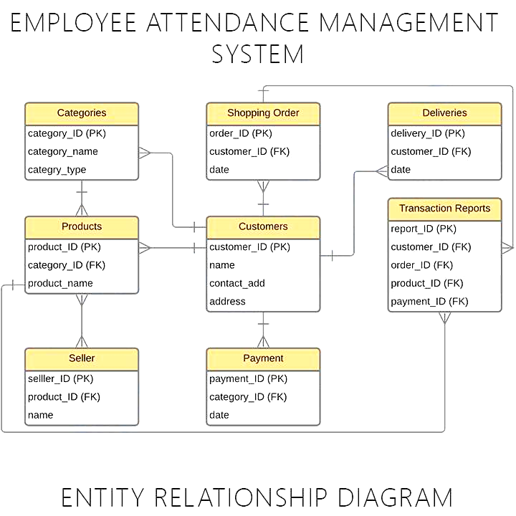

Figure 3.6: Proposed ERD

### **3.9 Summary**

This chapter defined the system’s requirements, design, and ethical rules. The proposed model leverages interviews and observation to address gaps in existing e-commerce systems, with a focus on flexible order review and secure POD.

# CHAPTER FOUR

# RESULTS AND DISCUSSION

## 4.1 Design and Implementation Results

This section presents the design and implementation of Subme online application for making orders online.

## 4.2 Homepage

The homepage for the design subme consists of the following features; Products, Cart, My Orders, register, all categories and the Search tabs, as presented in Figure 4.1.

The functions of each of these tabs are hereby explained in the succeeding subsections that follows.

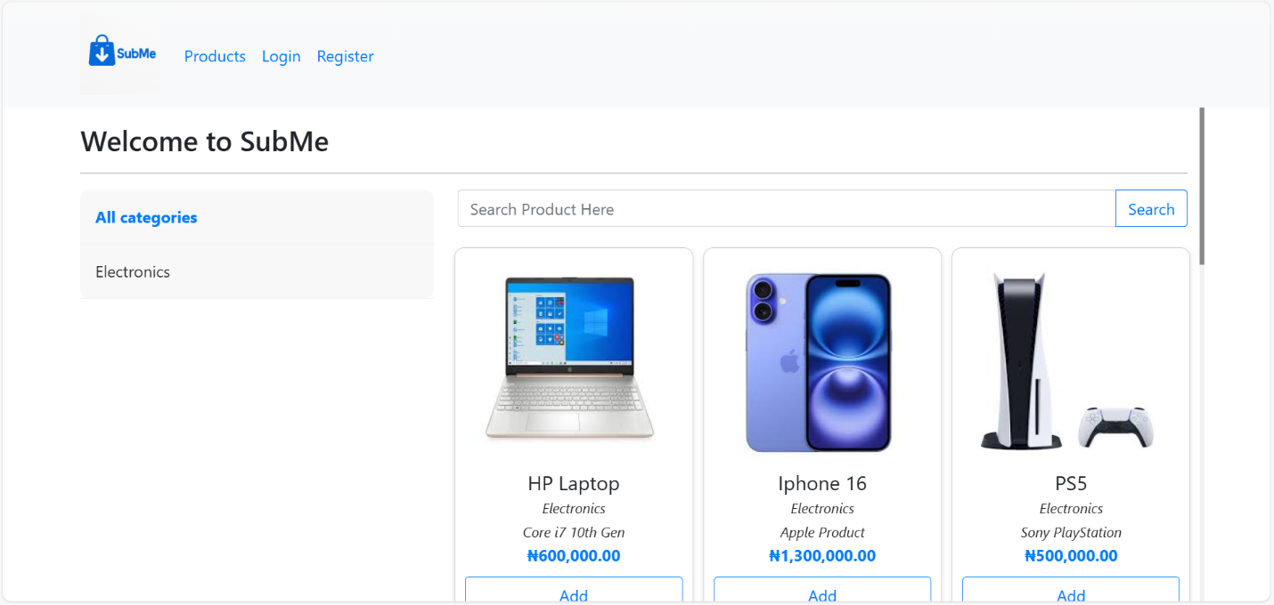

**Figure 4.1** Homepage

## 4.2 The Register Tab

The register tab presented in Figure 4.2, enables new clients/user who will like to make use of the Subme platform for purchase to register first, thereafter, the client/user can explore the full features of Subme.

New client/user need to provide the following details to register on the Subme platform; full name, username, email, password, contact and address. Thereafter, the new client/user can click on create account for such client/user to become active.

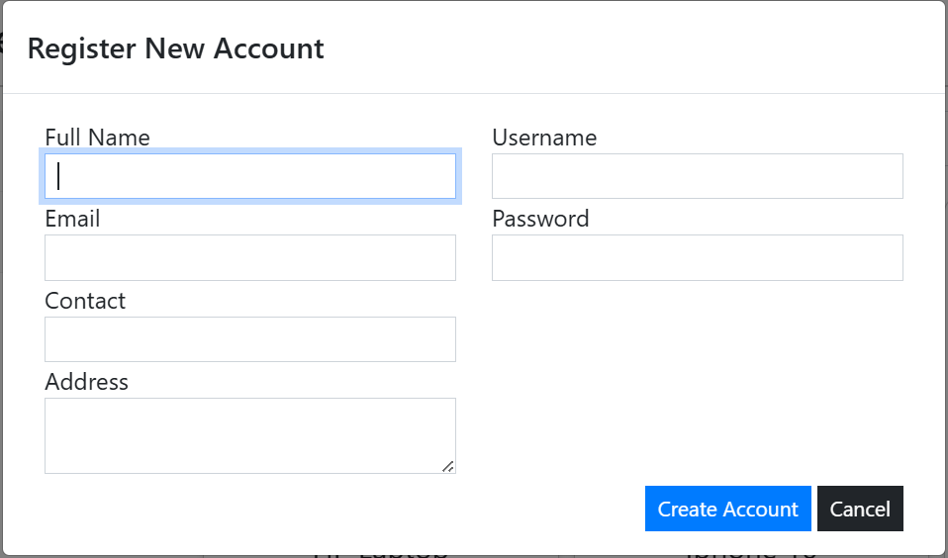

**Figure 4.2** Register Tab

A successful registered client/user will now need to provide login details before he/she can now login to Subme platform, Figure 4.3 presents the interface credential Login page for client/user to provide login details, such as username and password before the client/user can now click on Login to get access.

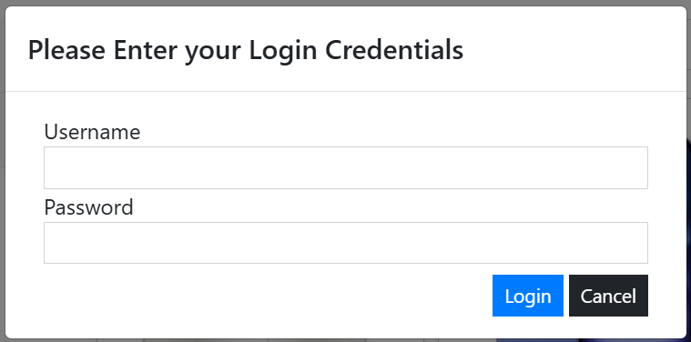

**Figure 4.3** Credential Login Page

## 4.3 Login Welcome Page

The Login Welcome page presented in Figure 4.4, compose of the following features; the registered tab now changed to the name of the registered new client/user with the “Hello” word attached to the client/user name. The client/user can now have access to view, select, add and make order of products.

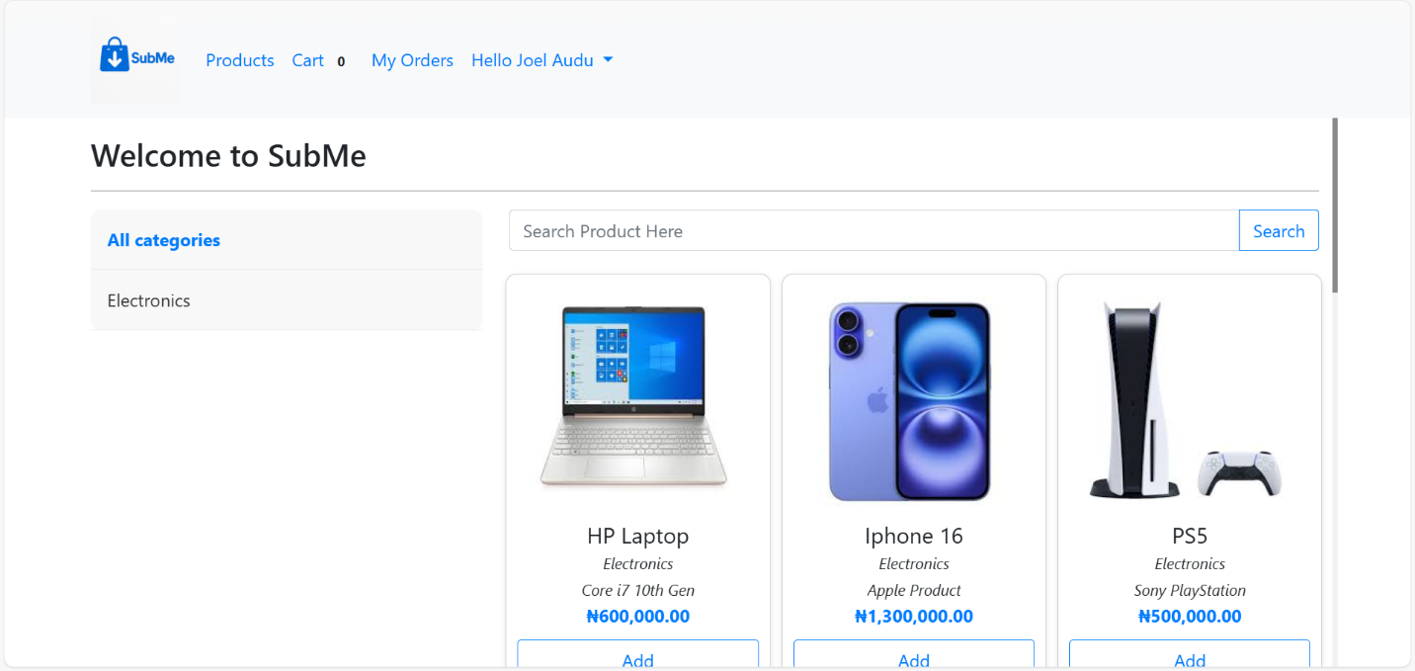

**Figure 4.4** Login Welcome Page

### 4.3.1 Add to cart

The Add to Cart is a feature that enable registered client/user to select product(s) of choose and add to cart, for forward onward delivery. In this interface, product name can be view, alongside the specification as well as the cost. After the registered client/user click on Add to Cart, a confirmation popup appears and then the registered client/user can click on ok. Figure 4.5 present the Add to Cart interface.

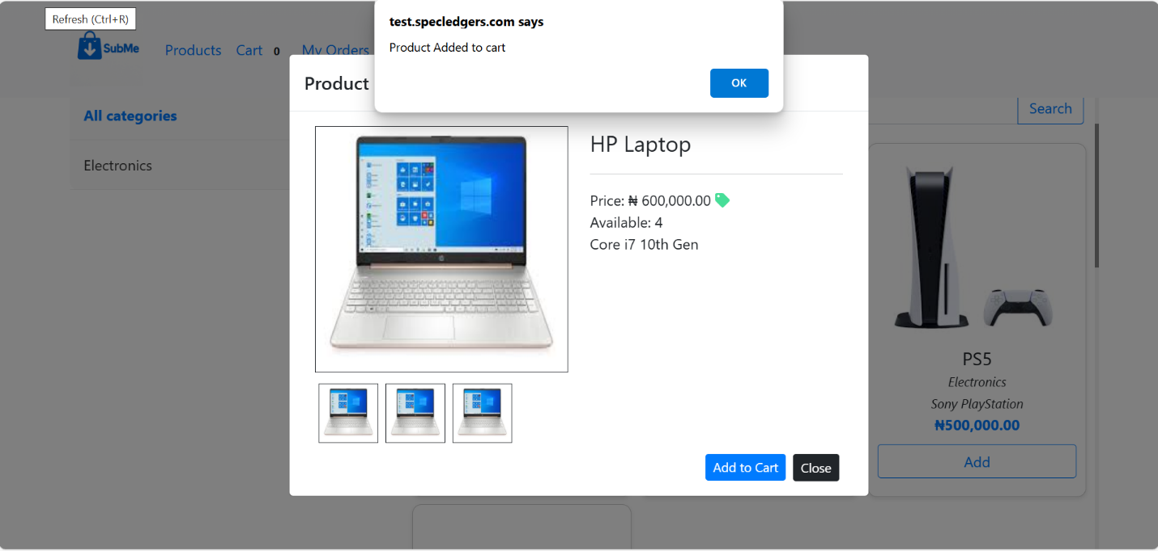

**Figure 4.5** Add to Cart Interface

### 4.3.2 Cart Interface

The Cart interface presented in Figure 4.6 is the feature that shows product(s) that have been selected and added to the cart by the registered client/user. The number of products ordered can be seen displayed at the Cart tab, of which from the Figure 4.6, it can be seen as 1, the amount of the product can also be seen. The registered client/user can now proceed to click on checkout, which servs as the final confirmation of the ordered product, registered client/user still have the option of deleting the product using the delete icon tab, if such client/user no longer wish to proceed with the ordered product.

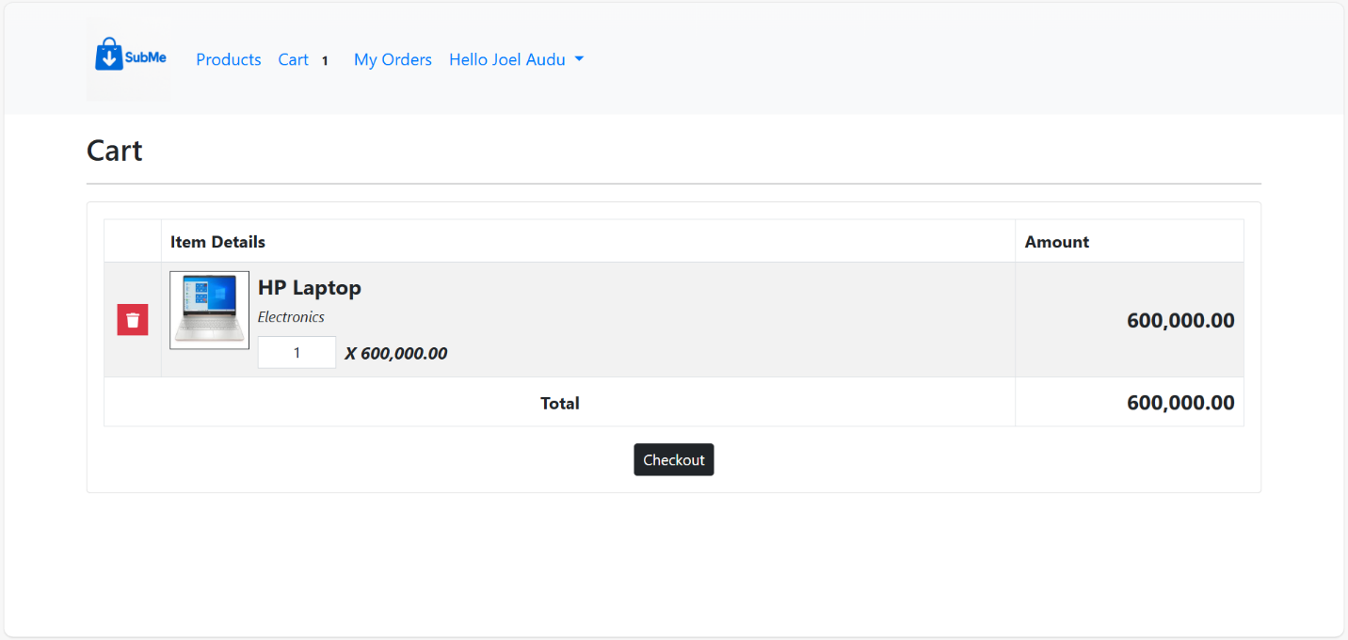

**Figure 4.6** Add to Cart interface

### **4.3.3** Checkout Interface

The Checkout interface precede the Cart interface have the features of Delivery Location, from which the registered client/user can select where the ordered product can be delivered, and then the Delivery Address Other Information which is the detailed point of locating the registered client/user.

Thereafter, the registered client/user can now click on Place Order or Cancel tab to conclude the Checkout process.

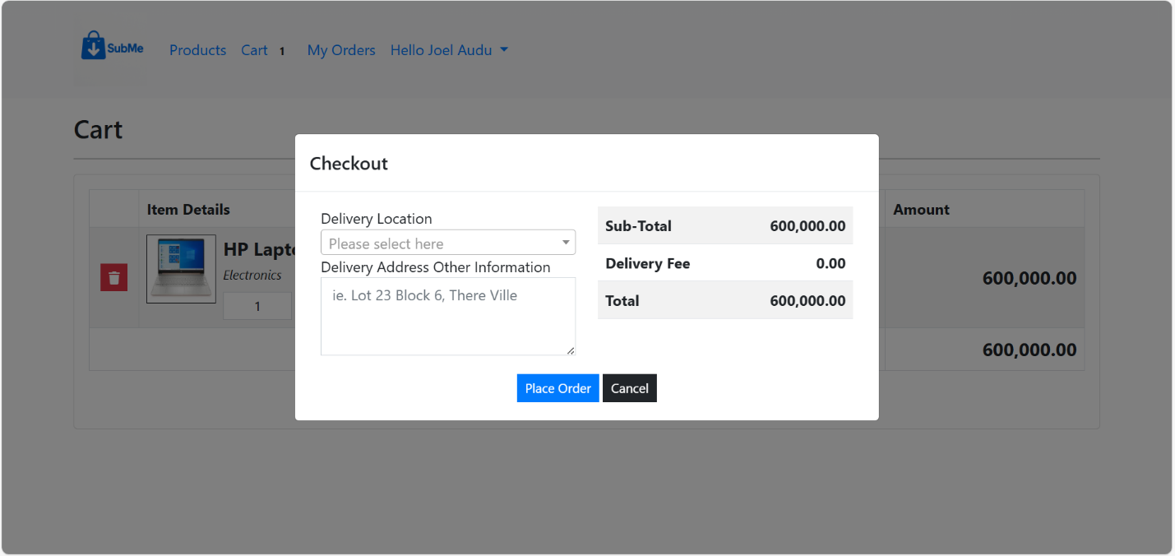

**Figure 4.7** Checkout Interface

A successful checkout will lead the registered client/user to the next page “Order successfully placed.” as presented in Figure 4.8, and next is the Order List and Order Detail interface.

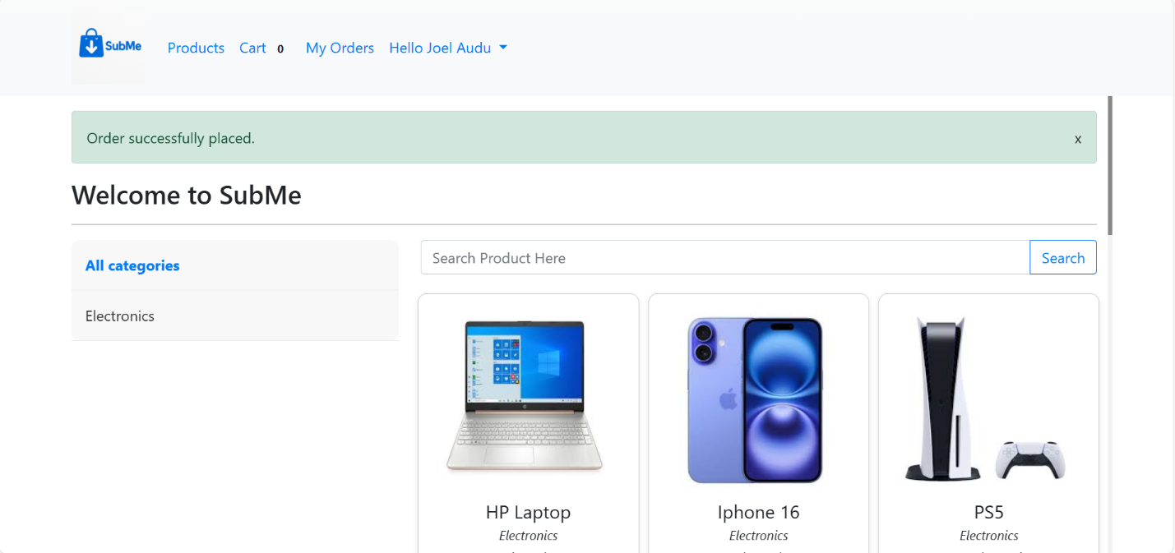

**Figure 4.8** Order Successfully Placed Interface

## 4.4 Oder List Interface

The Order List interface gives the registered client/user a preview of product ordered with details like DateTime Created, Transaction Pode, Customer Name, Items, Total Amount, Status and Action. Giving information about when product order was initiated, the transaction identification number, the registered client/user name, number of products ordered, summary of the product cost, the delivery state and the action which enable the ordered detail view respectively. Figure 4.9 present the Order List interface.

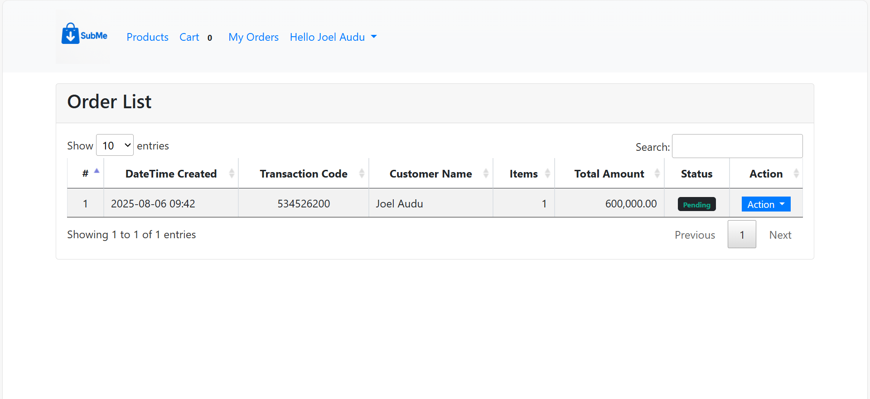

**Figure 4.9** Order List Interface

### 4.4.1 The Action Tab

The Action tab which has the View dropdown feature as presented in Figure 10, gives access to the registered client/user full summary of the product (Order Details) been ordered such as the Transaction Pode, the Status, Date Created and Delivery Address as discussed in the preceding subsections. Other information that can be seen are the Quantity (QTY) of ordered product, the specification (Item Details) as well as the cost of the product ordered (Amount). Figure 4.11 depicts the View dropdown detail from the Action tab.

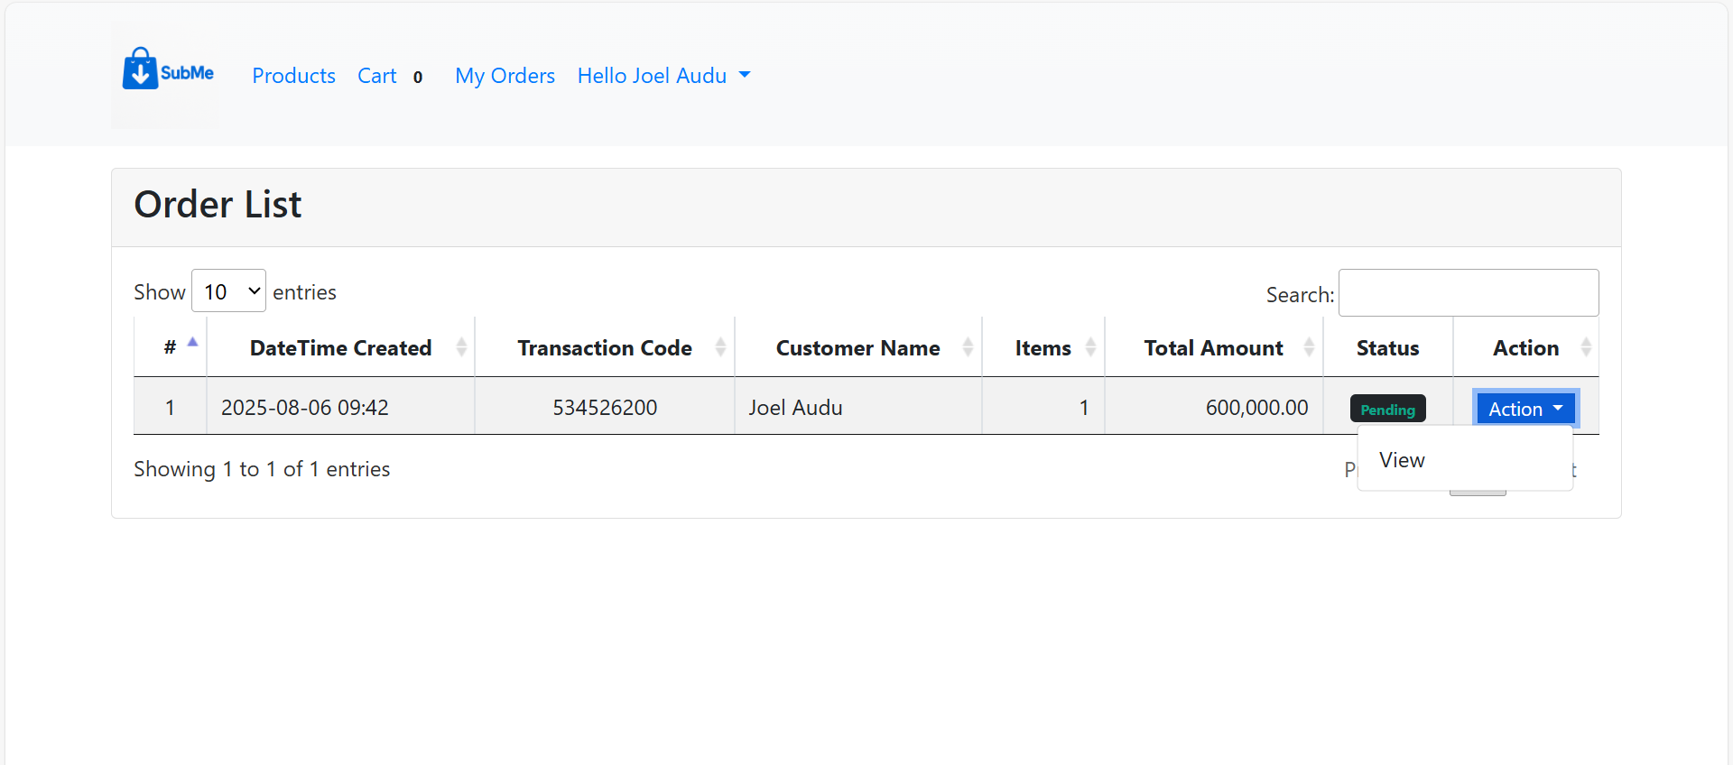

**Figure 4.10 T**he Action Tab

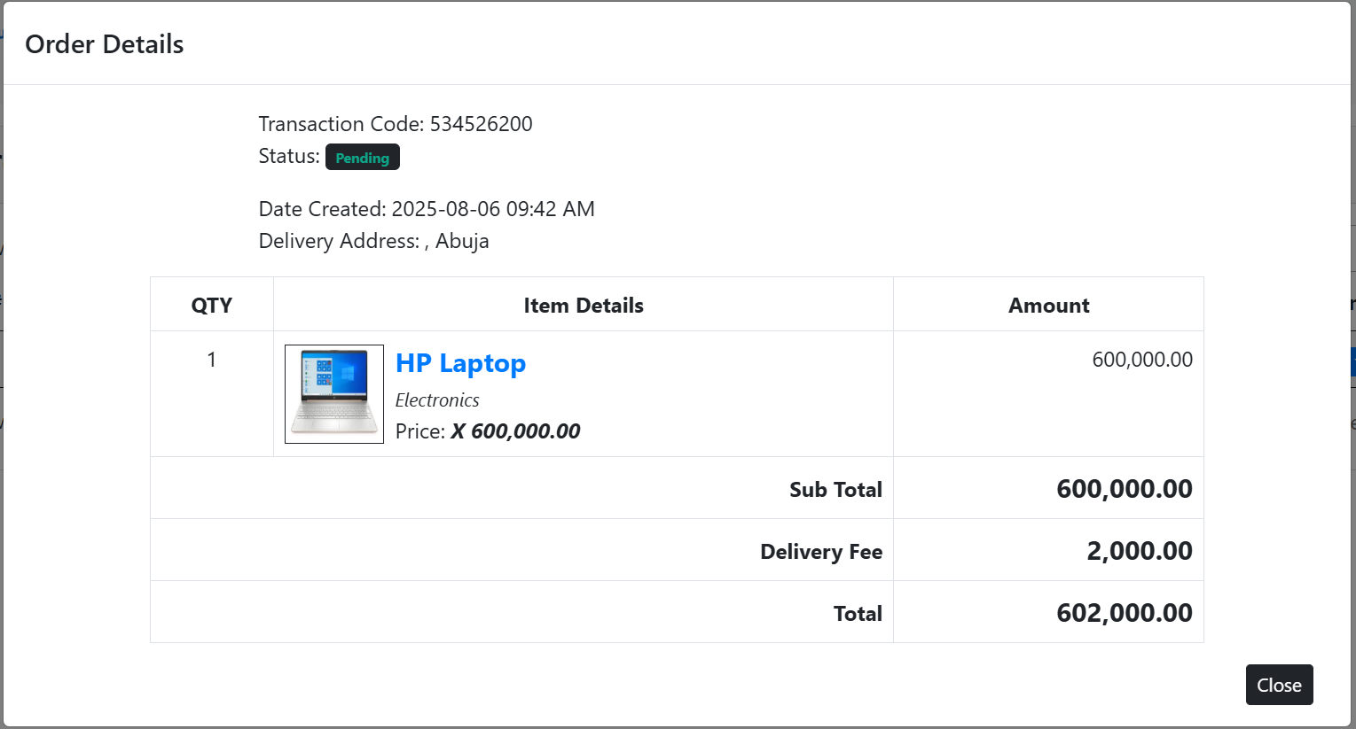

**Figure 4.11** The View Dropdown Detail from the Action Tab.

### 4.4.2 Manage Account Tab

The Manage Account Tab Figure 4.12 has the dropdown feature of Logout, that is to exit the Subme platform.



**Figure 4.12** Manage Account Tab

The Manage Account Function allows the registered client/user to update their details such as Full Name, Contact, Email, Address, and Username, as shown in Figure 4.13. The registered client/user can also decide to make changes to his or her password in this interface as well, after all operation are done successfully, the registered client/user can now click on update tab to complete the process of updating his or her information on the Subme platform.

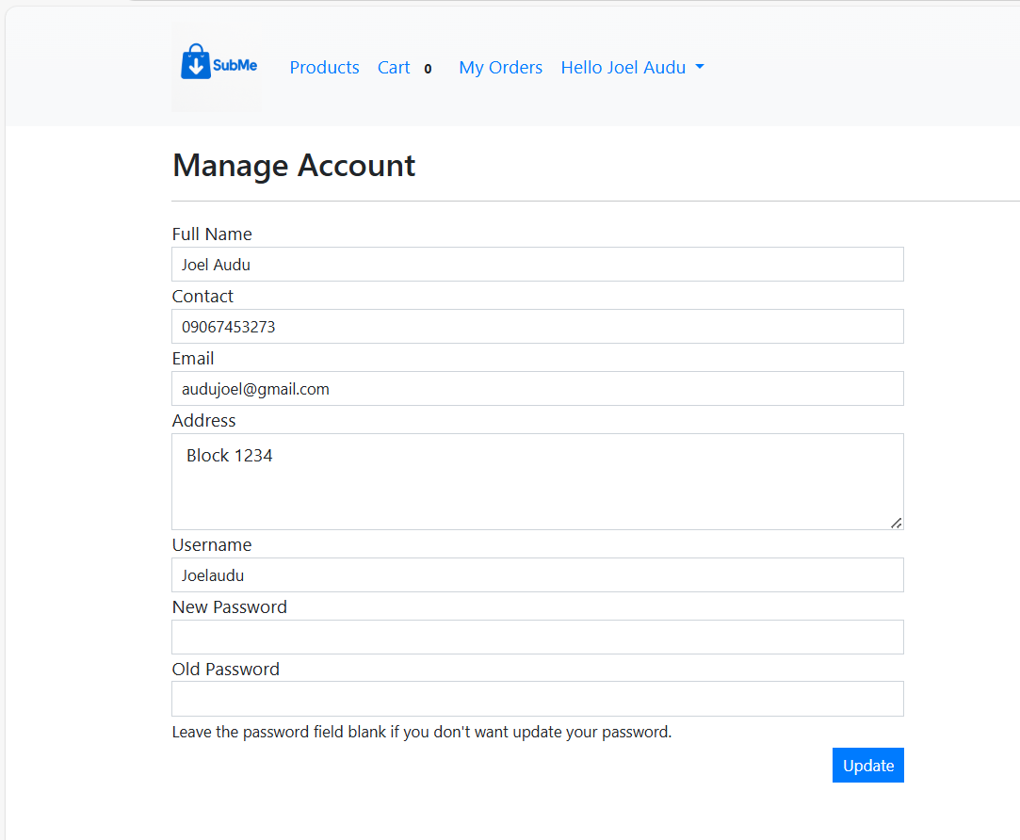

**Figure 4.13** The Manage Account Function Interface

**REFERENCE**

Jain, V., Malviya, B. I. N. D. O. O., & Arya, S. A. T. Y. E. N. D. R. A. (2021). An overview of electronic commerce (e-Commerce). Journal of Contemporary Issues in Business and Government, 27(3), 666.

Nasution, M. D. T. P., & Surya, D. H. (2025). Reassessing Payment Methods in E-Commerce: Why Consumers Prefer Cash on Delivery. Journal Business Administration: Entrepreneurship and Creative Industry, 4(1), 22-30.

Rayport, J. F., & Jaworski, B. J. (2003). Introduction to e-commerce. McGraw-Hill, Inc..

Halaweh, M. (2018). Cash on delivery (POD) as an alternative payment method for e-commerce transactions: Analysis and implications. International Journal of Sociotechnology and Knowledge Development (IJSKD), 10(4), 1-12.

Heng, M. S. (2003). Understanding electronic commerce from a historical perspective. Communications of the Association for Information Systems, 12(1), 6.

Okofu, S. N., Bisina, J., Okumoku-Evroro, O., & Akazue, M. I. (2024). CASH ON DELIVERY RISK MITIGATION CMRR MODEL. Journal of the Management Sciences, 61(9), 142-155.

Anjum, S., & Chai, J. (2020). Drivers of payment-on-delivery method of payment in e-commerce shopping: evidence from Pakistan. Sage Open, 10(3), 2158244020917392.

Alfarizi, M., & Sari, R. K. (2023). Adoption of cash on delivery (POD) payment system in shopee marketplace transaction. Procedia Computer Science, 227, 110-118.

Bakar, R., Fauziyah, N., & Rahmat, A. (2025). Do consumers perceive impulsive buying and pain of payment?: E-commerce transactions using pay later, e-wallet, and cash-on-delivery. Gadjah Mada International Journal of Business, 27(1), 31-59.

Kabir, M. A., Saidin, S. Z., & Ahmi, A. (2015, October). Adoption of e-payment systems: a review of literature. In International conference on e-commerce (pp. 112-120).

Panetta, I. C., Leo, S., & Delle Foglie, A. (2023). The development of digital payments–Past, present, and future–From the literature. Research in International Business and Finance, 64, 101855.

Usman P.J (2022) Design and implementation of an e-commerce system.

Hendricks, S., & Mwapwele, S. D. (2024). A systematic literature review on the factors influencing e-commerce adoption in developing countries. Data and Information Management, 8(1), 100045.

Yusuf, A., Gaffar, V., Hurriyati, R., & Wibowo, L. A. (2022, December). E-trust in e-commerce: a systematic literature review. In 3rd Borobudur International Symposium on Humanities and Social Science 2021 (BIS-HSS 2021) (pp. 638-644). Atlantis Press.

Mumu, J. R., Saona, P., Mamun, M. A. A., & Azad, M. A. K. (2022). Is trust gender biased? A bibliometric review of trust in E-commerce. Journal of Internet Commerce, 21(2), 217-245.

Vatrapu, S. R. (2014) Design and Implementation of E-Commerce Site for Online Shopping. All Capstone Projects. 79. <https://opus.govst.edu/capstones/79>

Rihidima, L. V. C., Abdillah, Y., & Rahimah, A. (2022). Adoption of Cash on Delivery Payment Method in E-commerce Shopping: A Value-based Adoption Model Approach. Jurnal Manajemen Teori dan Terapan, 15(3).

Zhang, Y and Wang, R. (2014). Comparison of E-payment of the B2C E-commerce in China from the Security and Trust Perspective. International Journal of Security and Its Applications8(3), 325-338

Achiando, H. A. (2019). E-commerce strategy adoption and performance of micro and small enterprises: A case of private security firms in Nairobi County, Kenya. IOSR Journal of Business and Management, 21(7), 35-64.

Amobi, O.M. (2023). Advantages and disadvantages of cash on delivery in E-commerce. Retrieval from: [https://medium.com/@mariaamobi/advantage-and-disadvantages-of-payment-on-delivery-in-e-commerce-43f7b11962f9](https://medium.com/@mariaamobi/advantage-and-disadvantages-of-cash-on-delivery-in-e-commerce-43f7b11962f9)

Fastercapital, (2023). Simplifying payment: How Cash On Delivery Transforms Online Shopping. Retrieved from: [https://fastercapital.com/content/Simplifying-Payments--How-Payment-on-delivery-Transforms-Online-Shopping.html](https://fastercapital.com/content/Simplifying-Payments--How-Cash-on-Delivery-Transforms-Online-Shopping.html)

Sasu, D. D. (2022). E-commerce in Nigeria –Statistics and Facts. In Statista. <https://www.statista.com/topics/6786/e-commerce-in-nigeria/>.

Okofu, S. N., Bisina, J., Okumoku-Evroro, O., & Akazue, M. I. (2024). Cash on delivery risk mitigation cmrr model. Journal of the Management Sciences, 61(9), 142-155.

Chiejina, C., & Olamide, S. E. (2014). Investigating the Significance of the 'Pay on Delivery' Option in the Emerging Prosperity of the Nigerian e-commerce sector. Journal of Marketing and Management, 5(1), 120.